

**KK14203**

OBJECT-ORIENTED PROGRAMMING

PROJECT 2

|  |  |
| --- | --- |
| **Name** | **Matric No** |
| Mohd Farhan Bin Aliuddin | BI17110005 |

1. Java Code

import java.io.*;

import java.util.*;

import java.util.Calendar;

import java.awt.event.*;

import java.awt.*;

import javax.swing.*;

import java.io.File;

import java.io.FileWriter;

import java.util.Scanner;

import java.io.FileNotFoundException;

class doctor extends JFrame{

void new_doctor(){

JFrame doctor = new JFrame();

doctor.setTitle("Doctor Menu ");

doctor.setSize(650, 350);

doctor.setLocationRelativeTo(null);

doctor.setDefaultCloseOperation(JFrame.DISPOSE_ON_CLOSE);

doctor.setResizable(false);

JPanel docPanel = new JPanel();

docPanel.setLayout(new BorderLayout());

docPanel.setBackground(Color.lightGray);

docPanel.setLayout (null);

JLabel docMenu = new JLabel("Welcome to Doctor Menu");

JTextField doc_id = new JTextField();

doc_id.setText("Doctor ID");

JTextField doc_name = new JTextField();

doc_name.setText("Doctor Name");

JTextField doc_spec = new JTextField();

doc_spec.setText("Doctor Specialization");

JTextField doc_appt = new JTextField();

doc_appt.setText("Doctor Work Time");

JTextField doc_qual = new JTextField();

doc_qual.setText("Doctor Qualification");

JTextField doc_room = new JTextField();

doc_room.setText("Room No");

JButton addDoc = new JButton("Add New Entry");

JButton viewDoc = new JButton("View Current List of Doctors");

docPanel.add(docMenu);

docPanel.add(doc_id);

docPanel.add(doc_name);

docPanel.add(doc_spec);

docPanel.add(doc_appt);

docPanel.add(doc_qual);

docPanel.add(doc_room);

docPanel.add(addDoc);

docPanel.add(viewDoc);

docMenu.setBounds (15, 30, 200, 25);

doc_id.setBounds (15, 70, 100, 25);

doc_name.setBounds (15, 100, 450, 25);

doc_spec.setBounds (15, 130, 200, 25);

doc_appt.setBounds (15, 160, 200, 25);

doc_qual.setBounds (15, 190, 200, 25);

doc_room.setBounds (15, 220, 100, 25);

addDoc.setBounds (15, 250, 130, 25);

viewDoc.setBounds (150, 250, 200, 25);

addDoc.addActionListener(new ActionListener(){

String saveDoc = "";

public void actionPerformed(ActionEvent de){

String tempSave = "Doctor ID: " + doc_id.getText() + "\nDoctor Name: " + doc_name.getText()

+ "\nDoctor Specialization: " + doc_spec.getText() + "\nDoctor Work Time: "

+ doc_appt.getText() + "\nDoctor Qualification: " + doc_qual.getText()

+ "\nDoctor Room No: " + doc_room.getText() + "\n\n";

saveDoc += tempSave;

try {

FileWriter myWriter = new FileWriter("DocFile.txt");

myWriter.write(saveDoc);

myWriter.close();

JFrame f=new JFrame();

JOptionPane.showMessageDialog(f,"Entry Added.");

} catch (IOException e) {

JFrame b=new JFrame();

JOptionPane.showMessageDialog(b,"Error!.");

e.printStackTrace();

}

}

});

viewDoc.addActionListener(new ActionListener(){

public void actionPerformed(ActionEvent dp){

String tempDoc = "";

try {

File myObj = new File("DocFile.txt");

Scanner myReader = new Scanner(myObj);

while (myReader.hasNextLine()) {

String data = myReader.nextLine() + "\n";

tempDoc += data;

}

myReader.close();

} catch (FileNotFoundException e) {

JFrame b=new JFrame();

JOptionPane.showMessageDialog(b,"Error!.");

e.printStackTrace();

}

JFrame f= new JFrame();

JTextArea area=new JTextArea(tempDoc);

area.setBounds(10,30, 600,600);

f.add(area);

f.setSize(700,700);

f.setLayout(null);

f.setVisible(true);

}

});

doctor.add(docPanel);

doctor.show();

}

}

class patient extends JFrame{

void new_patient(){

JFrame patient = new JFrame();

patient.setTitle("Patient Menu ");

patient.setSize(650, 350);

patient.setLocationRelativeTo(null);

patient.setDefaultCloseOperation(JFrame.DISPOSE_ON_CLOSE);

patient.setResizable(false);

JPanel patPanel = new JPanel();

patPanel.setLayout(new BorderLayout());

patPanel.setBackground(Color.lightGray);

patPanel.setLayout (null);

JLabel patMenu = new JLabel("Welcome to Patient Menu");

JTextField pat_id = new JTextField();

pat_id.setText("Patient ID");

JTextField pat_name = new JTextField();

pat_name.setText("Patient Name");

JTextField pat_dis = new JTextField();

pat_dis.setText("Patient Disease");

String gender[]={"Male", "Female"};

JComboBox pat_gen = new JComboBox(gender);

JTextField pat_status = new JTextField();

pat_status.setText("Admission Status");

JTextField pat_age = new JTextField();

pat_age.setText("Patient Age");

JButton addPat = new JButton("Add New Entry");

JButton viewPat = new JButton("View Current List of Patients");

patPanel.add(patMenu);

patPanel.add(pat_id);

patPanel.add(pat_name);

patPanel.add(pat_dis);

patPanel.add(pat_gen);

patPanel.add(pat_status);

patPanel.add(pat_age);

patPanel.add(addPat);

patPanel.add(viewPat);

patMenu.setBounds (15, 30, 200, 25);

pat_id.setBounds (15, 70, 100, 25);

pat_name.setBounds (15, 100, 450, 25);

pat_dis.setBounds (15, 130, 200, 25);

pat_gen.setBounds (15, 160, 200, 25);

pat_status.setBounds (15, 190, 200, 25);

pat_age.setBounds (15, 220, 100, 25);

addPat.setBounds (15, 250, 130, 25);

viewPat.setBounds (150, 250, 200, 25);

addPat.addActionListener(new ActionListener(){

String savePat = "";

public void actionPerformed(ActionEvent pe){

String tempSave = "Patient ID: " + pat_id.getText() + "\nPatient Name: " + pat_name.getText()

+ "\nPatient Disease: " + pat_dis.getText() + "\nPatient Gender: "

+ pat_gen.getItemAt(pat_gen.getSelectedIndex()) + "\nPatient Admission Status: " + pat_status.getText()

+ "\nPatient Age: " + pat_age.getText() + "\n\n";

savePat += tempSave;

try {

FileWriter myWriter = new FileWriter("PatFile.txt");

myWriter.write(savePat);

myWriter.close();

JFrame f=new JFrame();

JOptionPane.showMessageDialog(f,"Entry Added.");

} catch (IOException e) {

JFrame b=new JFrame();

JOptionPane.showMessageDialog(b,"Error!.");

e.printStackTrace();

}

}

});

viewPat.addActionListener(new ActionListener(){

public void actionPerformed(ActionEvent pp){

String tempPat = "";

try {

File myObj = new File("PatFile.txt");

Scanner myReader = new Scanner(myObj);

while (myReader.hasNextLine()) {

String data = myReader.nextLine() + "\n";

tempPat += data;

}

myReader.close();

} catch (FileNotFoundException e) {

JFrame b=new JFrame();

JOptionPane.showMessageDialog(b,"Error!.");

e.printStackTrace();

}

JFrame g = new JFrame();

JTextArea area2 =new JTextArea(tempPat);

area2.setBounds(10,30, 600,600);

g.add(area2);

g.setSize(700,700);

g.setLayout(null);

g.setVisible(true);

}

});

patient.add(patPanel);

patient.show();

}

}

abstract public class HospitalManagement implements ActionListener{

public static void main(String args[]){

doctor d = new doctor();

patient p = new patient();

JFrame menu = new JFrame();

menu.setTitle("UMS Hospital Management System ");

menu.setSize(500, 200);

menu.setLocationRelativeTo(null);

menu.setDefaultCloseOperation(JFrame.EXIT_ON_CLOSE);

menu.setResizable(false);

JPanel panel = new JPanel();

panel.setLayout(new BorderLayout());

panel.setBackground(Color.orange);

panel.setLayout (null);

String months[] = {"Jan","Feb","Mar","Apr","May","Jun","Jul","Aug","Sep","Oct","Nov","Dec"};

Calendar calendar = Calendar.getInstance();

JLabel intro = new JLabel("Welcome to UMS Hospital Management System");

intro.setBounds (120, 5, 350, 30);

panel.add(intro);

JLabel time = new JLabel("Time: " + calendar.get(Calendar.HOUR) + ":" + calendar.get(Calendar.MINUTE) + ":" + calendar.get(Calendar.SECOND));

time.setBounds (15, 50, 100, 30);

panel.add(time);

JLabel date = new JLabel("Date: " + months[calendar.get(Calendar.MONTH)] + " " + calendar.get(Calendar.DATE) + " " + calendar.get(Calendar.YEAR));

date.setBounds (100, 50, 100, 30);

panel.add(date);

JLabel main1 = new JLabel("-------[ MAIN MENU ]-------");

main1.setBounds (170, 70, 200, 30);

panel.add(main1);

JButton doc1 = new JButton("Doctors");

JButton pat1 = new JButton("Patients");

doc1.setBounds (15, 110, 100, 25);

pat1.setBounds (120, 110, 100, 25);

panel.add(doc1);

panel.add(pat1);

doc1.addActionListener(new ActionListener(){

public void actionPerformed(ActionEvent x){

d.new_doctor();

} });

pat1.addActionListener(new ActionListener(){

public void actionPerformed(ActionEvent y){

p.new_patient();

} });

menu.add(panel);

menu.show();

}

}

1. Object Oriented Concept Implementation

* 3 Classes were implemented: class HospitalManagement, class patient, class doctor.
* 2 Polymorphism were implemented on 2 Classes: class doctor extends JFrame, class patient extends JFrame.
* 1 Abstract Class was implemented: abstract public class HospitalManagement.
* 4 Exception handler were implemented: line 78-84, line 97-102, line 187-192, line 206-211.

1. Read and Write Implementation

* The read implementation can be found in line 89-97 and line 198-206.

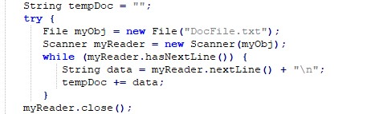

* The write implementation can be found in line 64-75 and line 172-184.

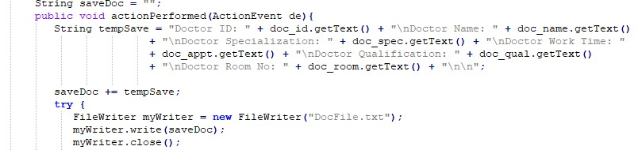

1. Manual

* 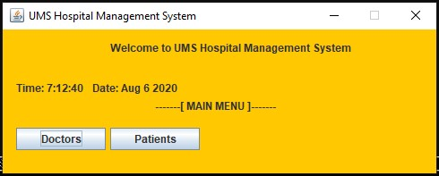This is the main menu for the system which allowed for user to begin their work by prompting to user to select on which operation they want to run.
* After picking between Doctors and Patients, user can now choose to add new entry into the system or view existing entry in the system.

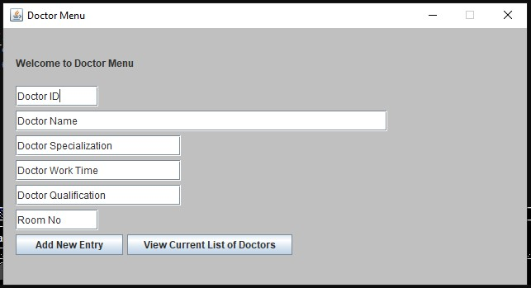

* 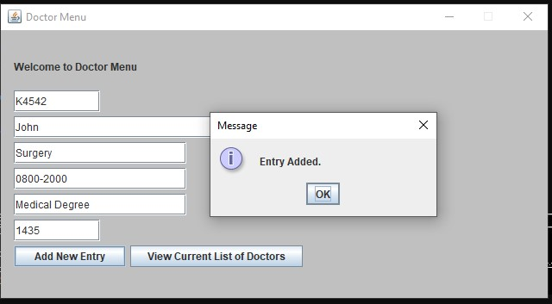 When user successfully added an entry, they will receive a popup of successful entry.
* 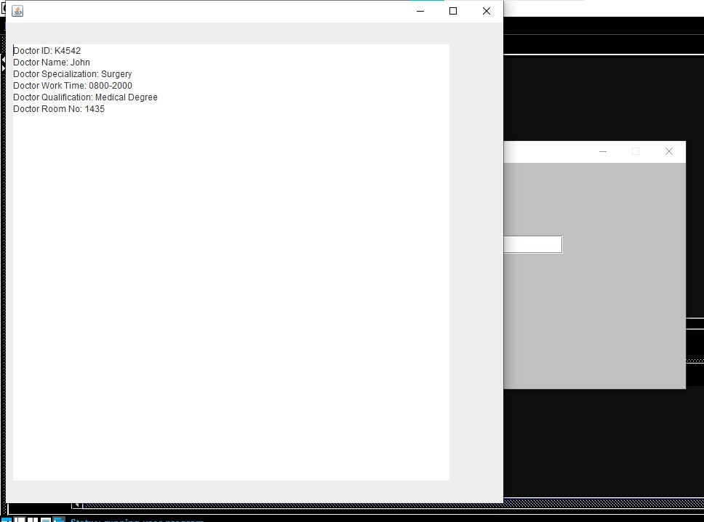User can view existing or newly added entry using the view current button.
* User can close the current window to return to the main menu.

